**MERGE SORT**

**Aim-** Write a C program to implement Merge Sort on array of structures

**Problem Statement –** Given a array of structures of items implement merge sort to sort the array of structures based on id number in assending order

**INPUT -**  The number of structures in the array = 7

Id num – 12,15,17,19,9,11,42

Item name – Candy ,Chocolate , Chips, Ice-cream , Biscuits ,Book, Pen

Price – 10,40,5,40,15,80,20

**OUTPUT –** Display the structures in sorted manner

**ALGORITHM –**

**i] Algorithm MergeSort (low,high)**

// Given a global array arr[low:high} and a global temporary array b and 0<=low<=high

{ if (low<=high ) then {

mid:= floor ((low+high)/2);

MergeSort (low,mid) ;

MergeSort(mid+1,high);

Merge (low,mid,high) ; } }

**ii] Algorithm Merge (low,mid,high )**

//Given two global arrays a,b and 0<=low<=mid<=high

{

i:=low ;

j:= mid +1 ;

k:= low ;

while ((i<=mid) and (j<=high)) do {

if ( arr[i] <= arr [j] ) then {

b[k] := arr[i] ;

i:= i+1 ;

} else {

e[k] := arr[j] ;

j := j+1 ;

}

X:= x+1 ; }

While (i<=mid) do {

b[k] : = arr[i] ;

i:= i+1 ; k:=k+1 ;}

while (j<=high) do {

b[k] := arr[j] ;

j:=j+1 ; k:=k+1 ;}}

**Space and time complexity :**

**I. Algorithm MergeSort**

**Time Complexity:**

i) **Best Case:**

* **O(n log n)**
* Even if the array is already sorted, the algorithm still recursively divides the array and merges it, leading to a time complexity of O(n log n).

ii) **Worst Case:**

* **O(n log n)**
* The algorithm always performs the same number of comparisons and divisions regardless of the input order.

iii) **Average Case:**

* **O(n log n)**
* On average, MergeSort divides the array and merges the sorted parts in logarithmic time for every level, with n operations at each level.

**Space Complexity:**

i) **Best Case:**

* **O(n)**
* The temporary array b requires linear additional space to store merged elements.

ii) **Worst Case:**

* **O(n)**
* Even in the worst case, the temporary array b is of size n, requiring linear additional space.

iii) **Average Case:**

* **O(n)**
* On average, the same temporary array is used, resulting in linear space usage.

**II. Algorithm Merge**

**Time Complexity:**

i) **Best Case:**

* **O(n)**
* Merging two sorted subarrays of total size n requires linear time in all cases.

ii) **Worst Case:**

* **O(n)**
* The merge process is always linear, irrespective of the input.

iii) **Average Case:**

* **O(n)**
* On average, merging two arrays of total size n takes linear time.

**Space Complexity:**

i) **Best Case:**

* **O(n)**
* A temporary array b of size n is used for merging.

ii) **Worst Case:**

* **O(n)**
* The same temporary array b is required regardless of the case.

iii) **Average Case:**

* **O(n)**
* On average, merging uses linear additional space for the temporary array.

**Recurance Equation :**

**I. Algorithm MergeSort**

The recurrence equation for MergeSort is:

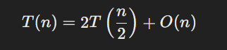

**II. Algorithm Merge**

No recurrence equation exists for the Merge algorithm itself since it is not recursive. Instead, it is part of MergeSort and is a linear process.

**PROGRAM –**

#include <stdio.h>

#include <string.h>

#include <time.h>

#define MAX 10

int n=0;

typedef struct {

    int id;

    char name[50];

    float price;

} Item;

Item a[MAX];

void merge(int min, int max) {

    int mid = (min + max) / 2;

    int i = min;

    int j = mid + 1;

    int k = 0;

    Item temp[MAX];

    while (i <= mid && j <= max) {

        if (a[i].id < a[j].id) {

            temp[k] = a[i];

            k++;

            i++;

        } else {

            temp[k] = a[j];

            k++;

            j++;

        }

    }

    while (i <= mid) {

        temp[k] = a[i];

        k++;

        i++;

    }

    while (j <= max) {

        temp[k] = a[j];

        k++;

        j++;

    }

    for (i = min, k = 0; i <= max; i++, k++) {

        a[i] = temp[k];

    }

}

void mergesort(int min, int max) {

    int mid;

    if (min < max) {

        mid = (min + max) / 2;

        mergesort(min, mid);

        mergesort(mid + 1, max);

        merge(min, max);

    }

}

void displayItems() {

    int i;

    printf("\nItems:\n");

    for (i = 0; i < n; i++) {

        printf("Item %d\n", i + 1);

        printf("ID: %d\n", a[i].id);

        printf("Name: %s\n", a[i].name);

        printf("Price: %.2f\n", a[i].price);

        printf("\n");

    }

}

int main() {

      printf ("*****************************************************");

    printf ("\n Roll number: 23B-CO-010\n");

    printf (" PR Number - 202311390\n");

    printf("*****************************************************\n\n\n");

     clock_t start, end;

    double cpu_time_used;

    int choice;

    int i;

    do {

        printf("\nMenu:\n");

        printf("1. Enter items\n");

        printf("2. Sort items by ID\n");

        printf("3. Display items\n");

        printf("4. Exit\n");

        printf("Enter your choice: ");

        scanf("%d", &choice);

        switch (choice) {

            case 1:

                printf("Enter the number of items (up to %d): ", MAX);

                  scanf("%d", &n);

                if (n > MAX) {

                     printf("You can only enter up to %d items.\n", MAX);

                      break;

                   }

                    printf("Enter the elements of the array:\n");

                     for (i = 0; i < n; i++) {

                          printf("Item %d\n", i + 1);

                           printf("ID: ");

                           scanf("%d", &a[i].id);

                    printf("Name: ");

                     scanf("%s", a[i].name);

                    printf("Price(in Rs.): ");

                    scanf("%f", &a[i].price);

          }

                break;

            case 2:

            start = clock();

                mergesort(0, n-1);

                printf("Items sorted by ID.\n");

                 end = clock();

    cpu_time_used = ((double) (end - start)) / CLOCKS_PER_SEC;

    printf("Time taken by Merge Sort: %f seconds\n", cpu_time_used);

                break;

            case 3:

                displayItems();

                break;

            case 4:

                printf("Exiting...\n");

                break;

            default:

                printf("Invalid choice. Please try again.\n");

        }

    } while (choice != 4);

    return 0; }

}

**INPUT –**

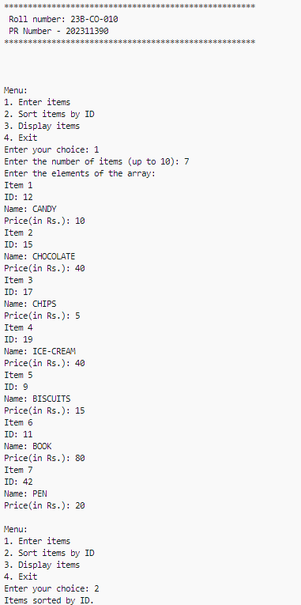

**OUTPUT –**

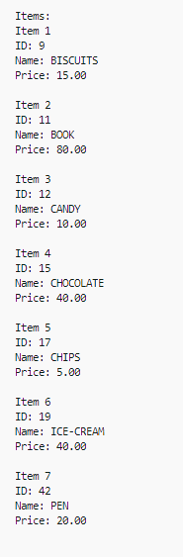

**TIME TAKEN –**



**CONCLUSION –** Array of structures was successfully sorted with any errors using merge sort algorithm